Unique_Products = Dataset['Product Name'].unique()

No_of_Unique_Products = Dataset['Product Name'].nunique()

print(f"There are {No_of_Unique_Products} Unique Products :-\n{Unique_Products}")

plt.bar(

x=["No Of Unique Products"], height=[len(Unique_Products)], width=0.5

)

for i, v in enumerate([len(Unique_Products)]):

plt.text(i, v + 0.5, str(v), ha="center")

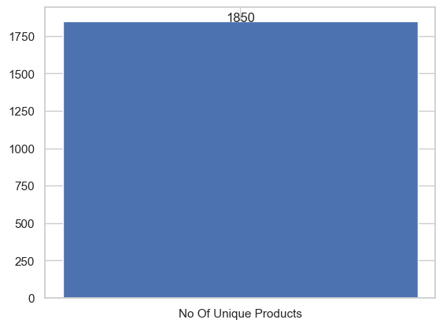plt.show()

Count_of_Each_Product = Dataset['Product Name'].value_counts()

Data = Count_of_Each_Product[:10]

Data_df = pd.DataFrame({"Product Name": Data.index, "Count": Data.values})

plt.figure(figsize=(20, 10))

ax = sns.barplot(data=Data_df, x="Product Name", y="Count", hue="Product Name")

for p in ax.patches:

ax.annotate(

format(p.get_height(), ".0f"),

(p.get_x() + p.get_width() / 2.0, p.get_height()),

ha="center",

va="center",

xytext=(0, 10),

textcoords="offset points",

fontsize=12,

color="black",

)

plt.xticks(rotation=45)

plt.xlabel("Product Name")

plt.ylabel("Count")

plt.title("Total Count of Each Product Ordered")

plt.show()

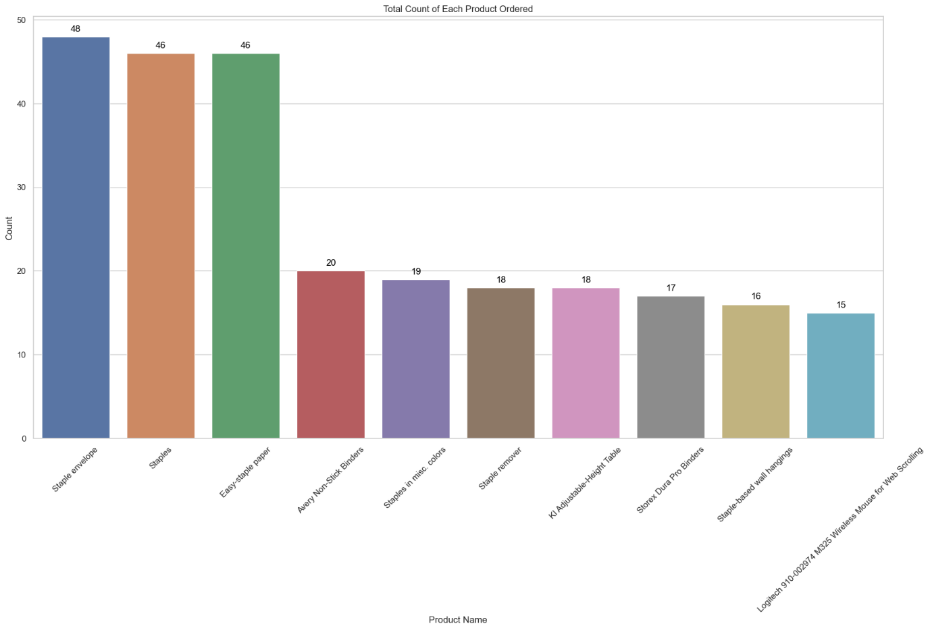

Category_wise_Sales_and_profit = Dataset.groupby("Sub-Category")[["Profit", "Sales"]].sum()

print(Category_wise_Sales_and_profit)

ax = Category_wise_Sales_and_profit.plot(kind="line", figsize=(12, 6))

plt.title("Category-wise Sales and Profit")

plt.xlabel("Sub-Category")

plt.ylabel("Amount")

plt.grid(True)

plt.legend(loc="upper right")

for column in Category_wise_Sales_and_profit.columns:

for index, value in enumerate(Category_wise_Sales_and_profit[column]):

ax.text(index, value, str(round(value, 2)), ha="center", va="bottom")

plt.tight_layout()

plt.show()

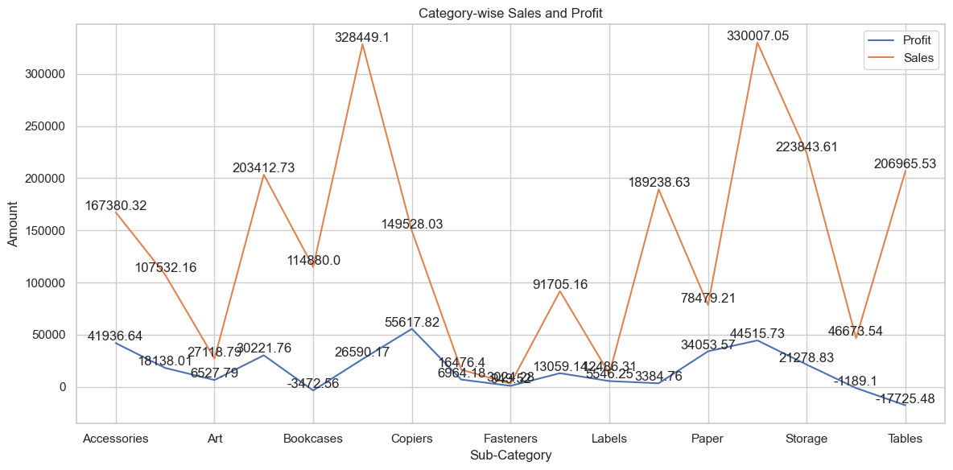

Technology_Distribution = (

Dataset[Dataset["Category"] == "Technology"]["Sub-Category"]

.value_counts()

.rename("Counts")

)

total_technology = Technology_Distribution.sum()

Technology_Distribution_with_percentage = (

Technology_Distribution / total_technology

) * 100

Technology_Distribution_with_percentage = (

Technology_Distribution_with_percentage.rename("Percentage")

)

Distribution_of_Technology = pd.concat(

[Technology_Distribution, Technology_Distribution_with_percentage], axis=1

)

print(Distribution_of_Technology)

plt.figure(figsize=(10, 6))

plt.pie(

Distribution_of_Technology["Counts"],

labels=Distribution_of_Technology.index,

autopct="%1.1f%%",

startangle=140,

)

plt.title("Distribution of Technology by Sub-Category")

plt.axis("equal")

plt.show()

